**Project Report**

**On**

**“Online Banking System”**

**Submitted in the Partial fulfillment of the requirement for the Award of Degree of**

**Bachelor of Technology**

**In**

**COMPUTER SCIENCE & ENGINEERING**

**Batch**

**(2017-2021)**



|  |  |
| --- | --- |
| **Submitted to**  **Er. Simi Luthra** | **Submitted by**  Shekhar Kashyap(1701367)  Ritesh Vohra(1701344)  Shrish Saini(1701370)  Sagar Gnawali(1701350) |

**DEPARTMENT OF COMPUTER SCIENCE & ENGINEERING**

**Amritsar College of Engineering & Technology, Amritsar(Autonomous college under UGC Act – 1956[2(f) and 12(B)] )**

###### ACKNOWLEDGEMENT

This is a humble effort to express my sincere gratitude towards those who have guided and helped me to complete this project.

A project is major milestone during the study period of a student. As such this project was a challenge to me and was an opportunity to prove my caliber. I am highly grateful and obliged to each and every one making me help out of problems being faced by me.

It would not have been possible to see through the undertaken project without the guidance of **Er. Simi Luthra** . It was purely on the basis of his experience and knowledge that we able to clear all the theoretical and technical hurdles during the development phases of this project work.

Last but not the least I am very thankful to our Head of Department **Er. Vinod Sharma** and all Members of Computer Science Department who gave us an opportunity to time problems while fulfilling need of an organization by making projects for them face real.

Software Requirement Specification

Of

Online Banking System

Introduction

This document, SRS is created to document the software requirements for the Banking System. A bank has several ATMs, which are geographically distributed and connected via a wide area network to a central server. A transaction is initiated when a customer inserts an ATM card into the card reader. Encoded on the magnetic strip on the back of the ATM card is the card number, the start date, and the expiration date. Cards that have been reported lost or stolen are also confiscated. If the PIN is validated satisfactorily, the customer is prompted for a withdrawal, query, or transfer transaction. Before a transfer transaction can be approved, the system determines that the customer has at least two accounts and that there are sufficient funds in the account to be debited. A customer may cancel a transaction at any time; the transaction is terminated and the card is ejected.

Basic Features

* Assuming the card is recognized, the system validates the ATM card to determine that the expiration date has not passed, that the user entered PIN matches the PIN maintained by the system, and that the card is not lost or stolen.
* The customer is allowed three attempts to enter the correct PIN; the card is confiscated if the third attempt fails.
* For approved query and transfer requests, a receipt is printed and card ejected.
* Customer records, account records, and debit card records are all maintained at the server.
* An ATM operator may start up and close down the ATM to replenish the ATM cash dispenser and for routine maintenance.

Objectives

The main objective of the Online Banking System is to manage the details of Accounts, Internet Banking, Transaction, Balance, Statement. The aim of e- banking services is to provide the customers a much faster services with low cost. It is usually used as an easier and faster way to connect with your bank and to access your banking information. It provides banking throughout the year 24/7 days from any place have internet access.

It provides well-organized cash management for internet optimization. It provides convenience in terms of capital, labour, time all the resources needed to make a transaction.

Scope of Project

Now all the business like commerce, trade, import, export, purchase and sale of goods is relying upon electronic banking. By using the advance electronic technology the banking services are fast and economical. There is a saving time an saving of money in the use of E.banking. If any country wants to work in the world market, it will have to improve the banking services at international level because old traditional banking is not acceptable in the changing global economy. The online banking facility has been provided by the large number of commercial banks. On other hand credit card facility is also available in the various commercial banks. Now every bank wants to attract the customers and for this purpose the offers the latest facilities so i seems that no any bank will survive in the market if he fails to provide up date facilities.

Functional Requirements

* **Register_Customer():**

The required data for registration of a new customer in the bank (Like Name, Address, Designation etc.)

* **Maintenance_Records():**

The required data for maintenance of all records of customer (Like account records, debit card records, Account type etc.)

* **Check_Balance():**

To checking or savings account, query the balance of an account.

* **Transfer_funds():**

To transfer funds from one account to another.

Non-Functional Requirements

* Software Requirements

This product is developed mainly using open source technologies like apache, php, gtk+ etc.

Frontend: GTK+ 2.8.20 , GCC 4.0.0, PHP 5.20 , Glade 2.10.1 (For CBS)

Backend: MySql 4.17 Web Server: Apache 2.2

Platform used: Fedora Core 4 Linux, Windows XP / Windows7/ Windows Vista Web Browser: Microsoft Internet Explorer 4.0,Mozilla ,Google Chrome or later.

* Hardware Requirements
* Standard pc
* Internet connection with good enough speed
* ATM
* Pentium IV 1.7 GHz class or better processor
* 128MB or more RAM (256 recommended)
* At least 500 MB Hardisk space.
* Smart mobile phone

Abbreviation

PIN: personal identification number

ATM: Automated Tele Machine

SRS: Software requirement specification

DFD-0 Level

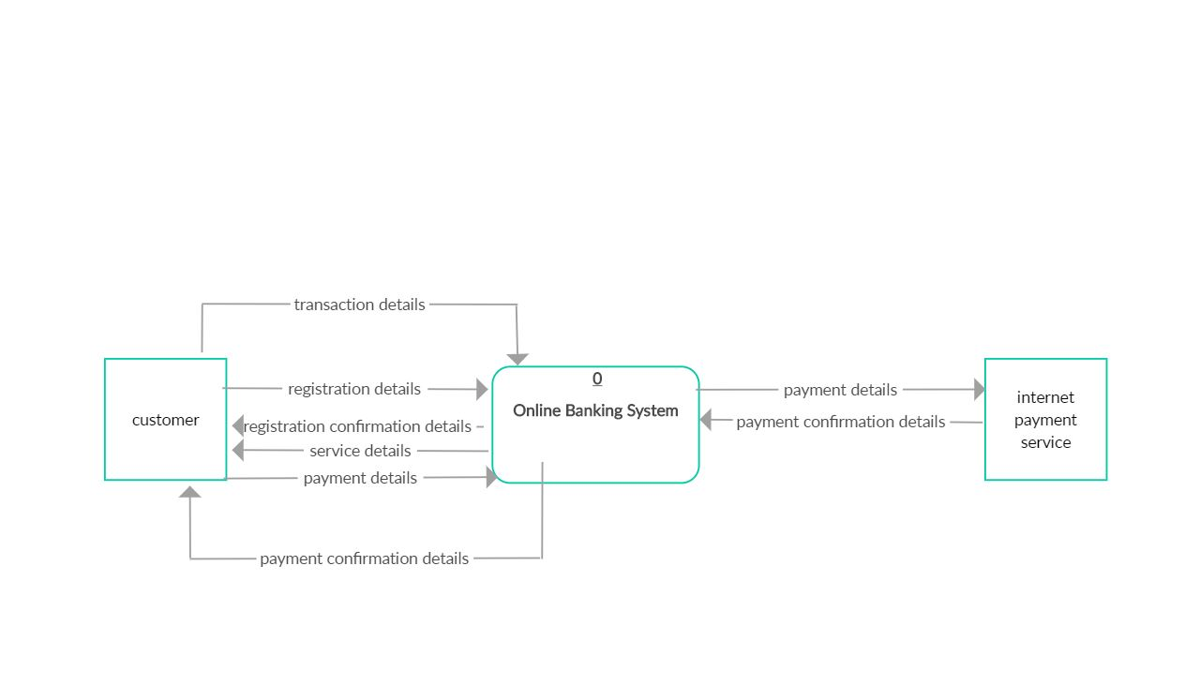

DFD-1 Level

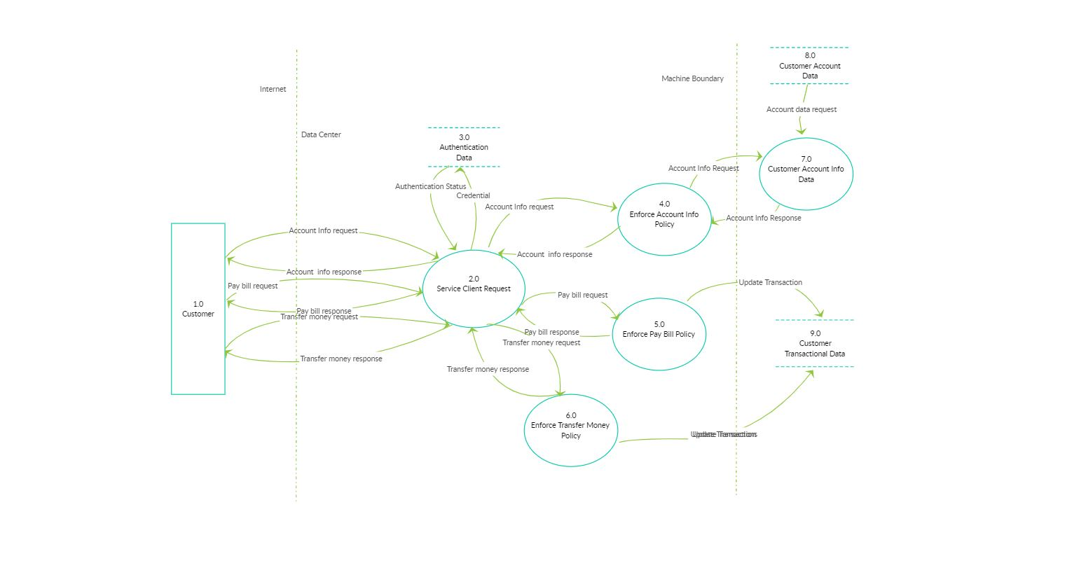

DFD-2 Level

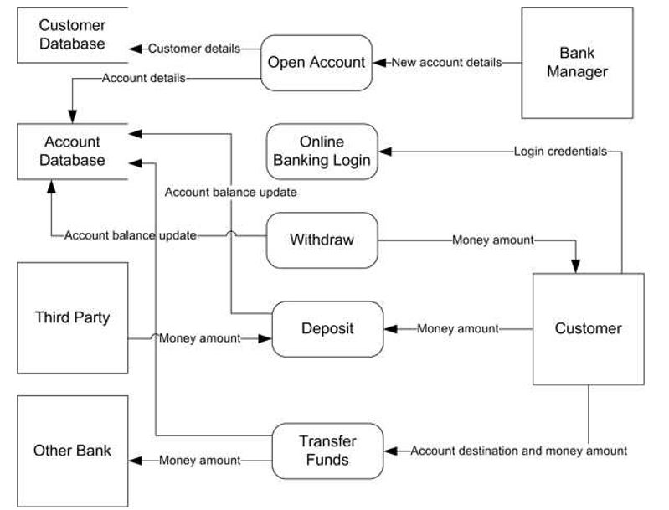

Use Case Diagram

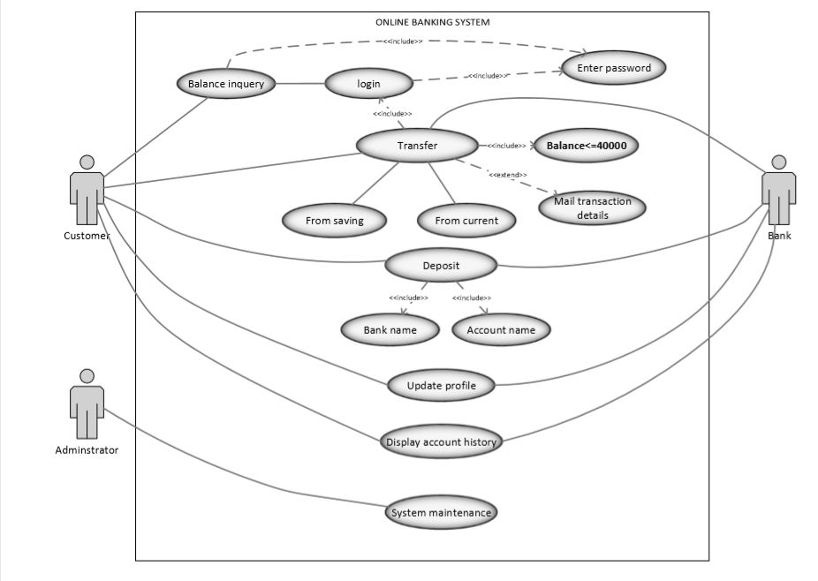

Class Diagram

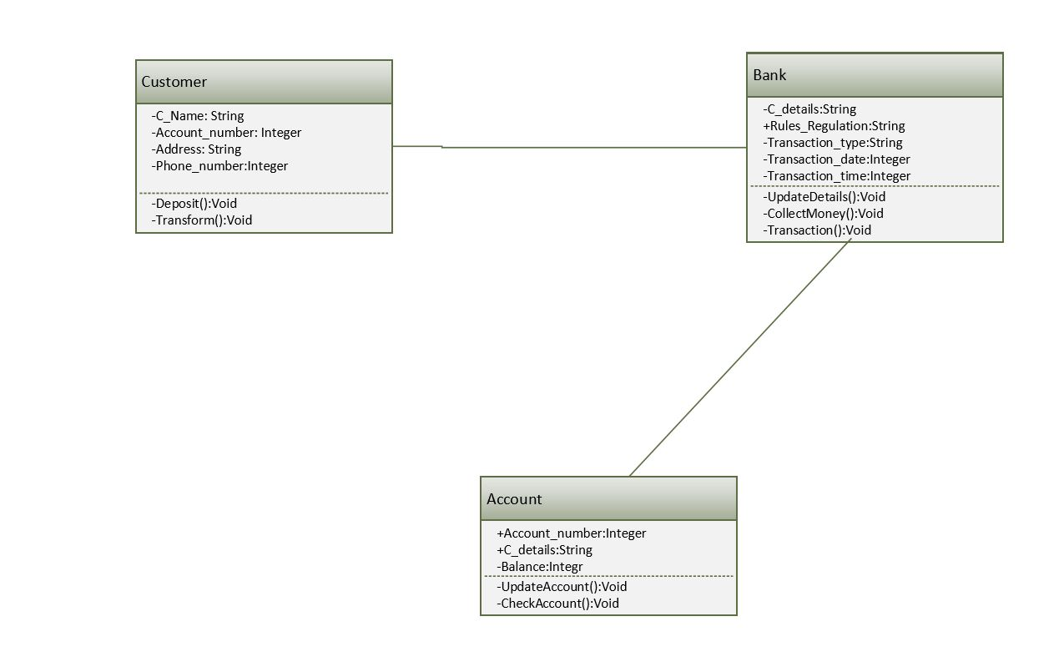

Object Diagram

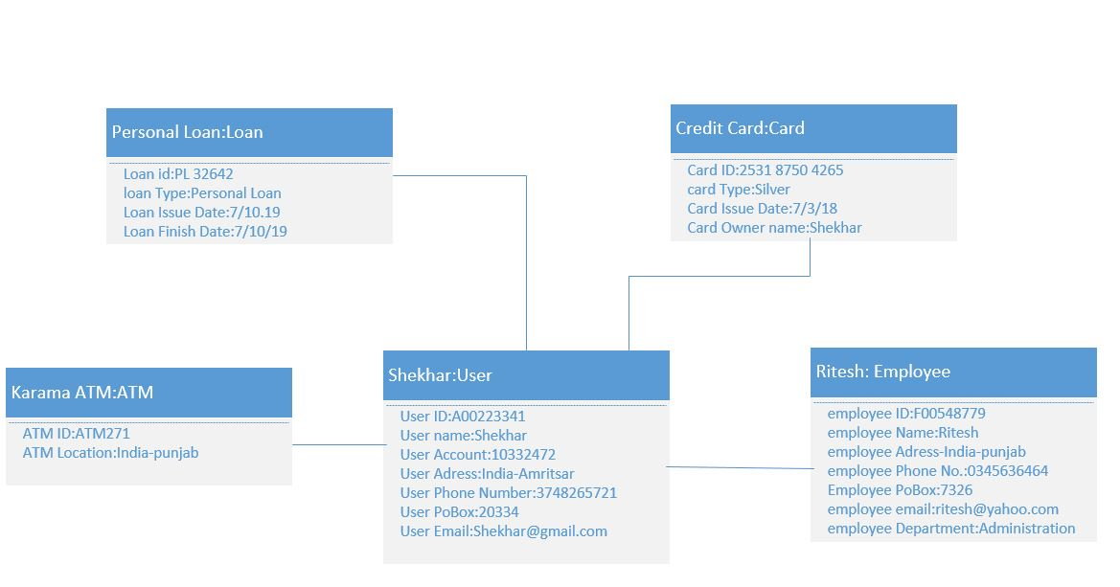

Activity Diagram

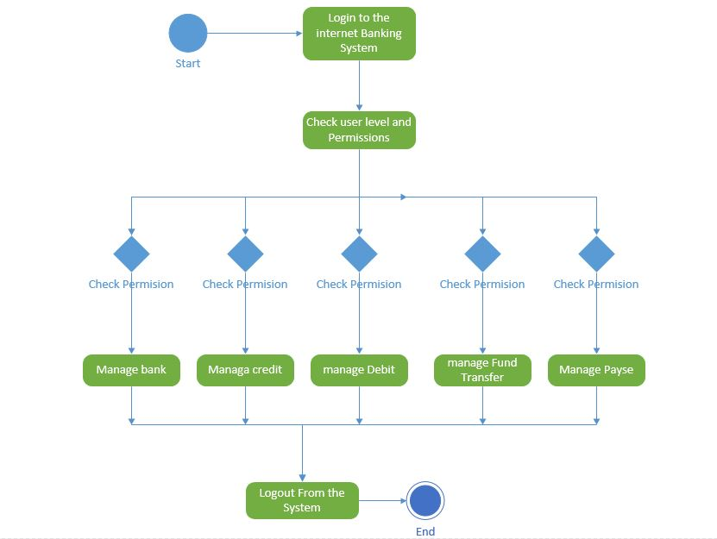

Collaboration Diagram

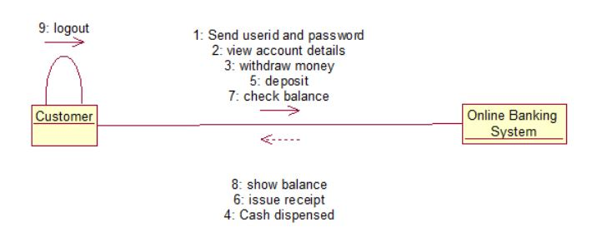

Sequence Diagram

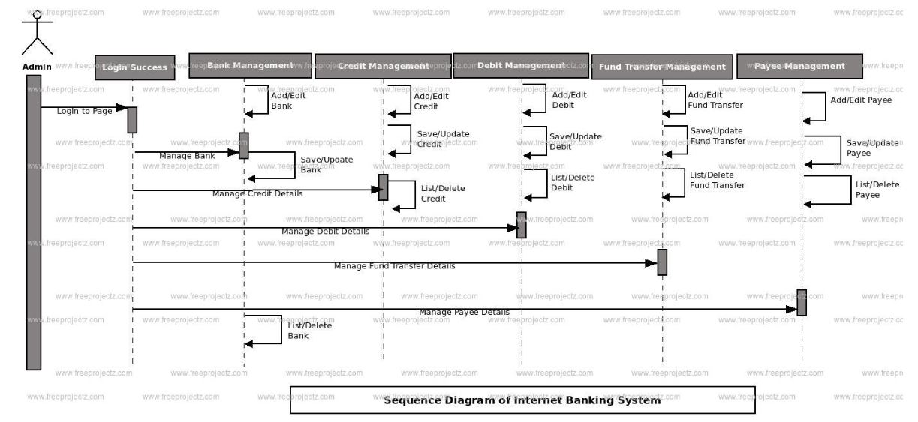

State Chart Diagram

